Salma Ehab Teama

DisCOVERY  Shebin-Elkom

Session 03 Word - ICDL

Page 1

|  |  |  |
| --- | --- | --- |
| Name | Age | Salary |
| ali | 20 | 1200 |
| mai | 22 | 1500 |
| maha | 30 | 1700 |

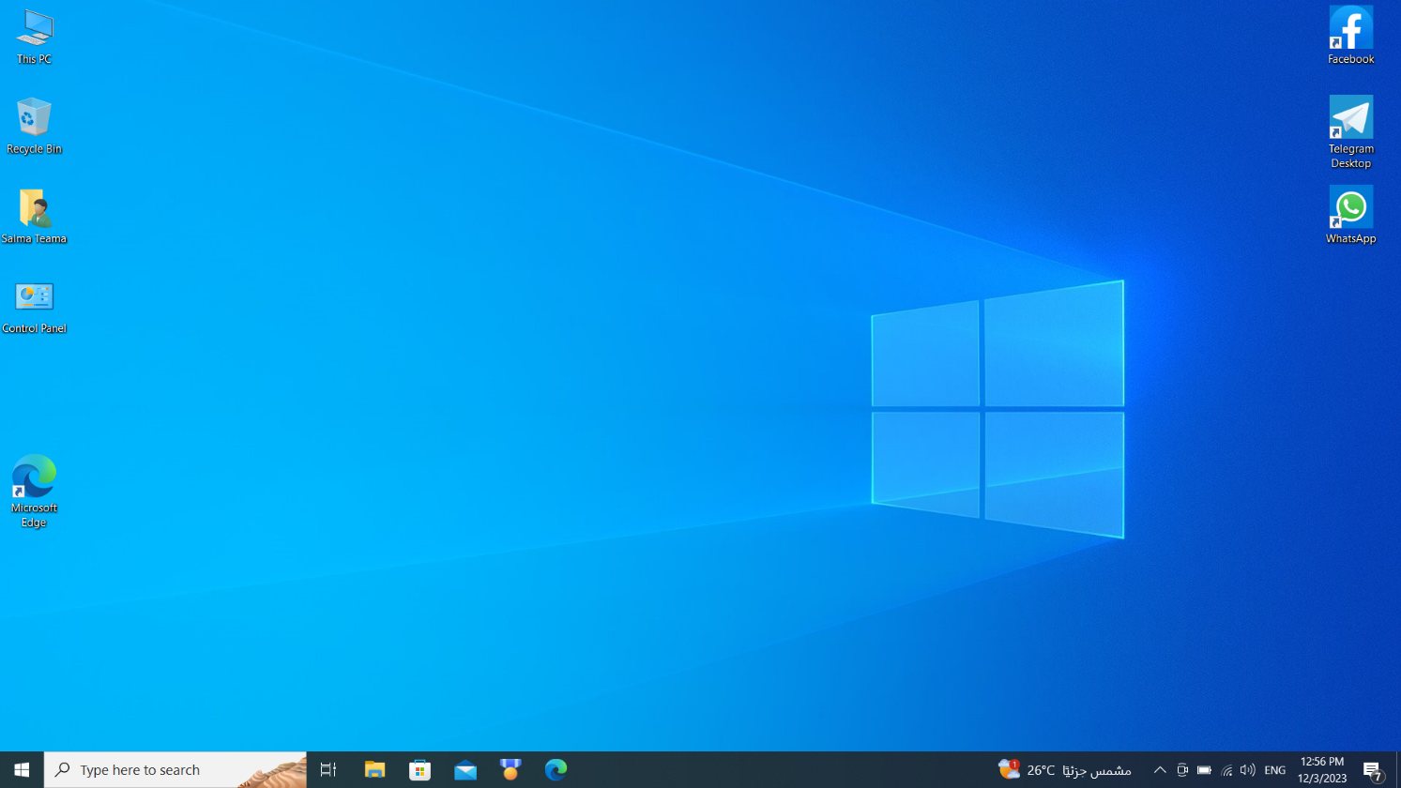

Page 2

Mazen



Page 03

Yaseen

Ali

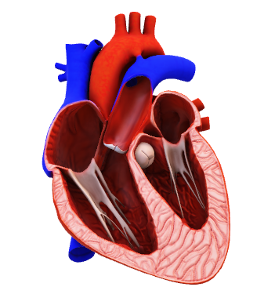

Page 04

Page 05

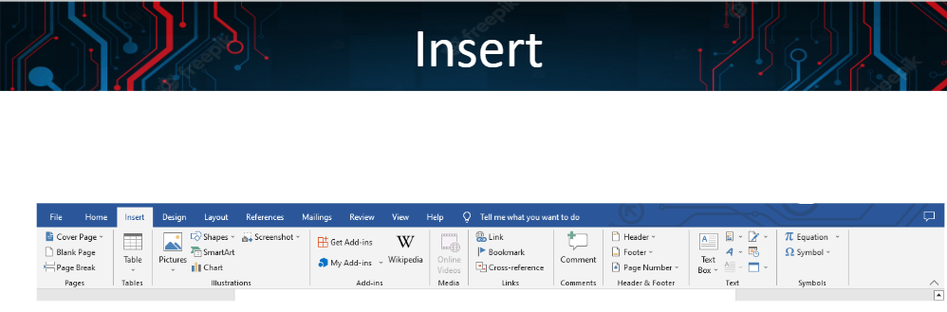

[](https://www.youtube.com/embed/1jbgUWsl1z4?feature=oembed)

Page 06

Gjg

∑

$${\left(5+12\right)}^{n}=\sum_{k=0}^{n}{\left({n \atop k}\right)x^{k}a^{n-k}}$$

h∑